# Dig lab-1

## Assign By: Sir Murtaza

From: Sumaira

Screenshot 1: In this command digging for “linkedin.com” severs is used.

Answer section is showing the NS (sever-name) for LinkedIn.

answer section shows the result for our command.


Screenshot 2: In this command “dig” is used, simply to view IP-address and additional information.

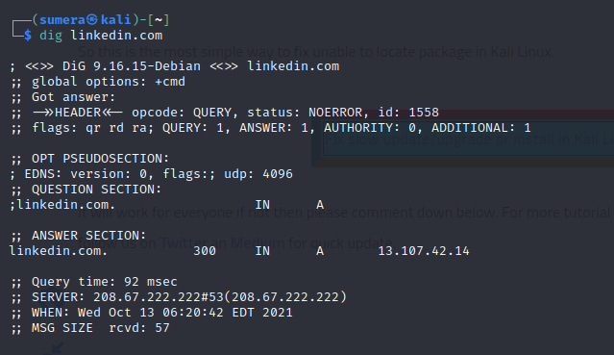

Screenshot 3: “A” in dig command is specially is use to view IPv4 address for targeted domain.

Ipv4 for linkedin.com is mentioned in answer section.

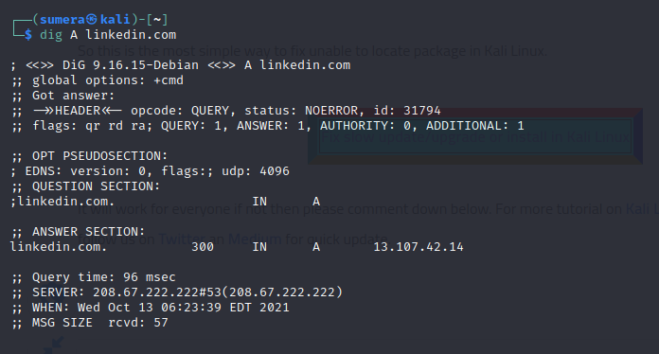

Screenshot 4: “AAAA” is used to view the IPv6 for targeted domain.

Ipv6 for linkedin.com is included in answer section to response to our command.

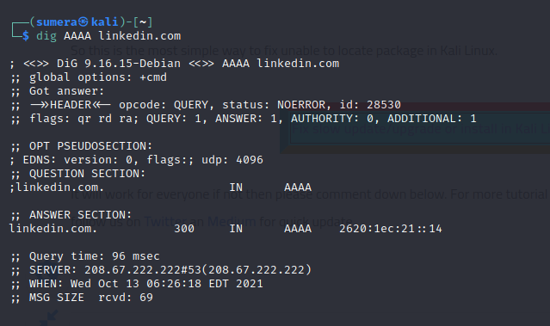

Screenshot 5: use of “MX” with dig is used to view all no. of mail-servers.

Mail-servers for linkedin.com are included in answer section.

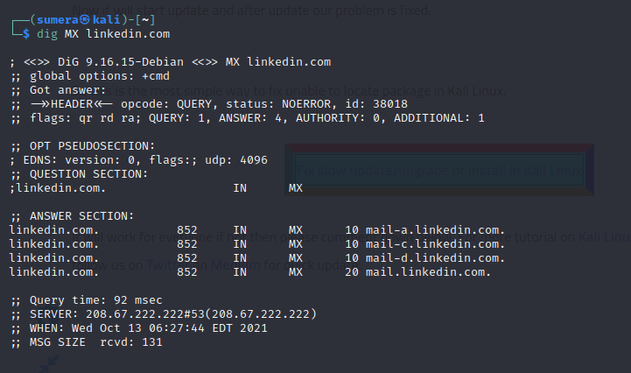

Screenshot 6: using the same command we can also view the primary mail server or the mail server used mostly by targeted domain.

In following screenshot the highest priority server for linkedin.com is one the is mention first in answer section.

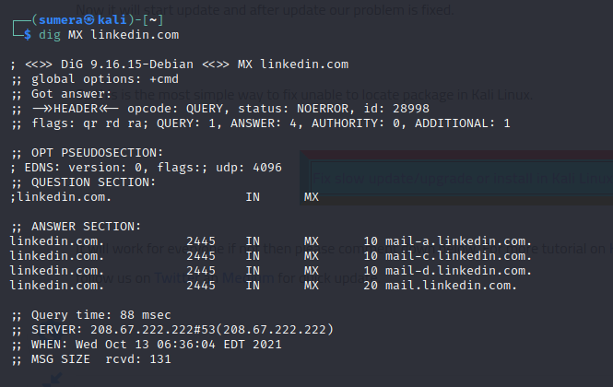

Screenshot 7: “CNAME” command with dig is used to view canonical name for a targeted domain.

As mention in answer section the canonical name for linkedin.com.

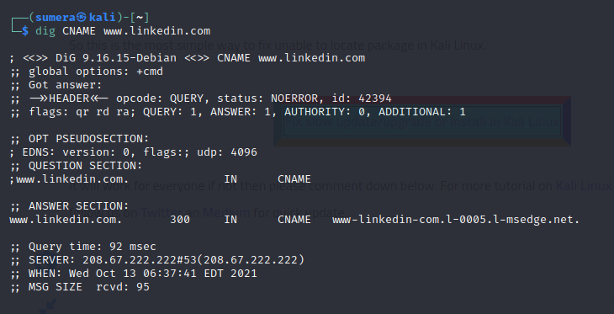

Screenshot 8: “CAA” is used to view certificate authorities for mentioned domain.

As answer section shows 0 result, that’s mean that there are no certificates authorities for linkedin.com.

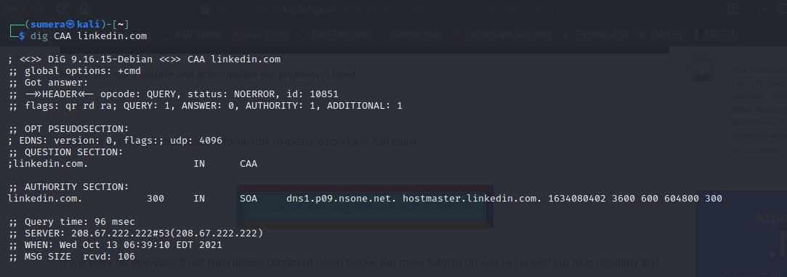

Screenshot 9: “TXT” is used to view flags for a domain.

Flags for linkedin.com are shown in answer.

